Data Science Documentation

Datasets:
- Training
- Validation

Reduction by using:
- PCA
- Kernel PCA
- LLE
- TSNE
Variance preserved in PCA transformations: [0.12592273 0.08201049 0.05513535]

3D Scatter Plots

PCA:

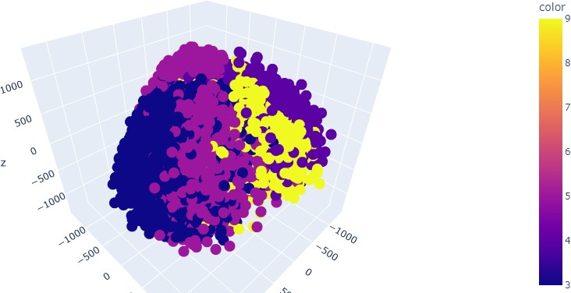

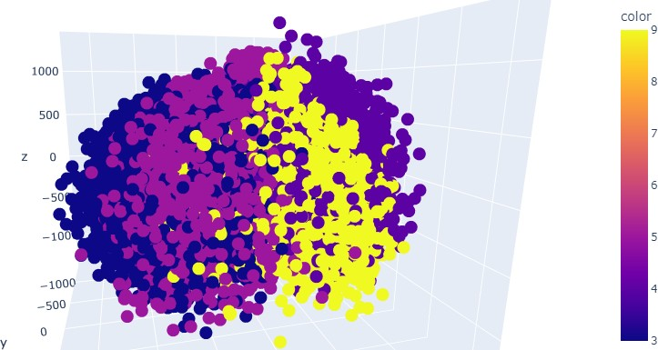

Kernel PCA:

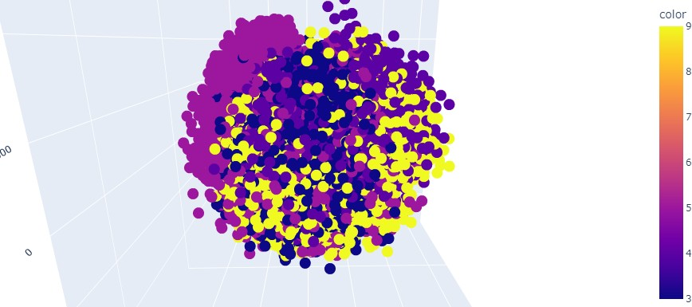

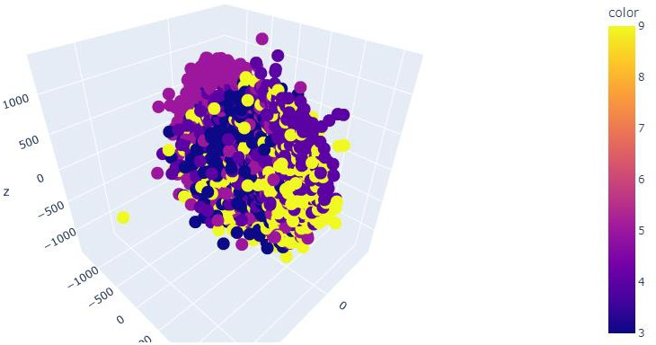

LLE:

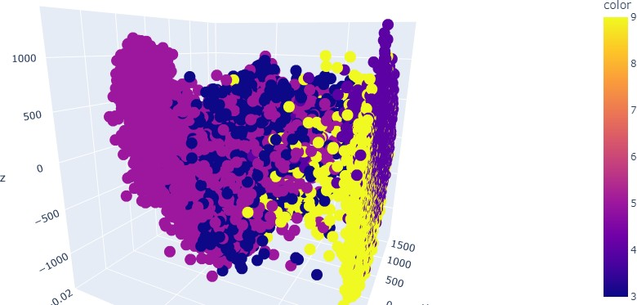

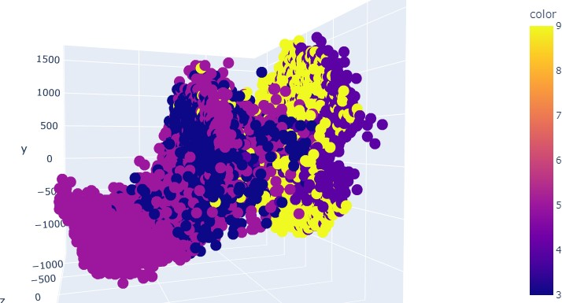

TSNE:

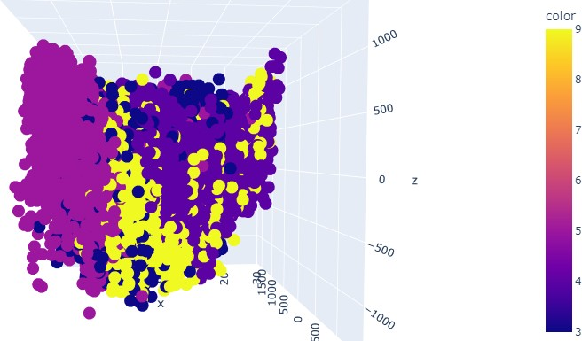

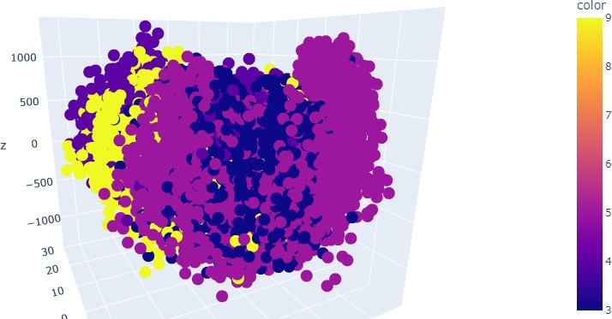

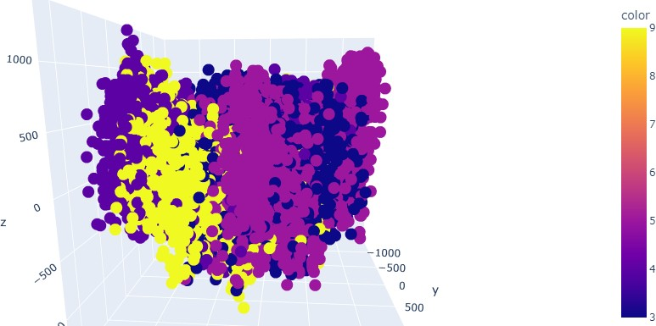

Verdict:
Upon the observation of the visualization of different reduction techniques, we can infer that the
TSNE and PCA separated the digits better than the rest.

Logistic Regression:

PCA:
Training Accuracy: 61.835475578406175
Validation Accuracy: 61.64911379398921

Kernel PCA:
Training Accuracy: 26.020565552699225
Validation Accuracy: 27.819162599537634

LLE:
Training Accuracy: 64.1388174807198
Validation Accuracy: 65.81042897508348

TSNE:
Training Accuracy: 95.12082262210797
Validation Accuracy: 24.017467248908297

SVM:

PCA:
Training Accuracy: 50.75064267352185
Validation Accuracy: 50.52658618032366

Kernel PCA:
Training Accuracy: 25.922879177377894
Validation Accuracy: 25.276136655535574

LLE:
Training Accuracy: 44.44215938303342
Validation Accuracy: 43.77087079373234

TSNE:
Training Accuracy: 96.09254498714654
Validation Accuracy: 24.96789108656563

Verdict:
Upon observation of the result of the accuracies, we can note that on the training dataset, TSNE
performed well and on the validation, LLE performed better.

